How can I help?
The bait is intended for wild animals – specifically raccoons. Everyone can help by keeping their pets inside or on leashes during the baiting time and for about five days afterwards. This will help to prevent your pet from getting the baits and gives raccoons a chance to eat the baits.

Important Reminders:
- Do not attempt to take a bait away from your pet! It is never a good idea to take food from the mouth of an animal. You may be bitten!
- Leave baits in place if possible. If the bait is out in the open where contact with pets or children could occur, put on gloves and toss it into deeper cover.
- Damaged baits should be placed in a baggie and disposed of in normal trash.
- If you have skin contact with either the bait or the pink liquid vaccine, wash the area of contact with soap and water.
- If you have eye or mucous membrane contact, rinse the area with water.
- If you have skin or mucous membrane contact (such as the eyes or mouth) with the pink liquid vaccine, please contact the Pennsylvania Department of Health (1-877-PA HEALTH) for additional information.
- Immediately call your physician and the Pennsylvania Department of Health (1877-PA HEALTH) if you develop a rash after contact with a bait.
- Please call the Pennsylvania Public Health Information Line 1-877-PA
HEALTH, the Erie Co. Dept. of Health 1814-451-6700, or the Allegheny Co. Health Department 1-412-687-2243 if you need advice.

Rabies: Six Ways to Protect Yourself and Your Family:
- Do not feed, touch or adopt wild animals, and be cautious of stray dogs and cats. Rabid animals do not always appear ill or vicious!
- Teach children to leave wildlife alone. Be sure your children know to tell you if an animal bites or scratches them.
- Have your veterinarian vaccinate your dogs, cats, or ferrets against rabies.
Keep pet vaccinations up-to-date.
- Tightly close garbage cans. Open trash attracts wild or stray animals to your home or yard.
- Feed your pets indoors; never leave pet food outside as this attracts wildlife.
- Call your doctor and your local health department for advice if an animal bites or claws you. Report the incident immediately!

The Oral Rabies Vaccination Project is conducted by the Pennsylvania Departments of Agriculture and Health, the Erie County Department of Health, Allegheny County
Health Department, the Pennsylvania Game Commission, the Centers for Disease Control and Prevention (CDC), and the U S Department of Agriculture Wildlife Services (USDA/APHIS/WS).
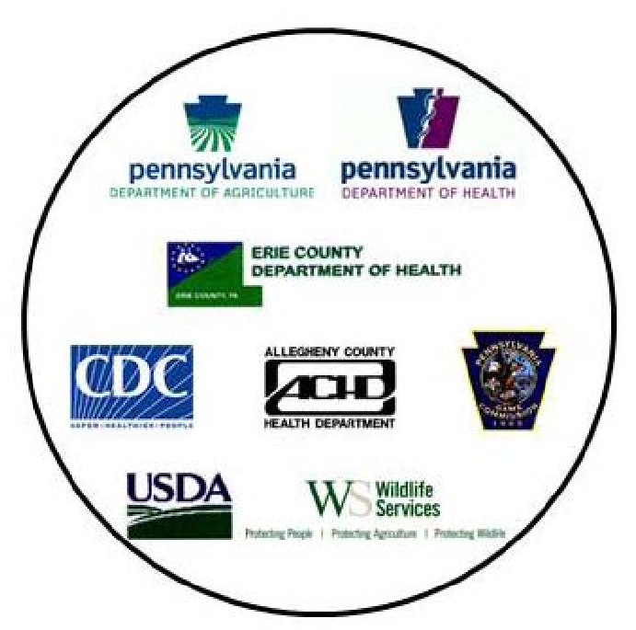

RACCOONS AND RABIES

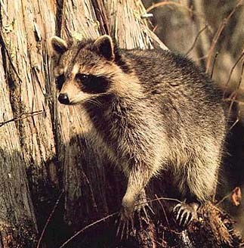

Questions and Answers
About Oral Rabies Vaccine
\

Why are there concerns about raccoons and rabies?
Raccoon rabies is found throughout Pennsylvania. It is a viral infection that can affect the nervous system of any mammal, including humans. The disease is almost always fatal to both people and animals. Raccoon rabies spreads rapidly and infects large numbers of raccoons. The disease often spreads to other wildlife and pets, making human exposure a real concern. To address this problem, federal, state and county agencies are participating in a combined program, to keep this animal epidemic from spreading further westward by attempting to eliminate or at least greatly reduce raccoon rabies in western Pennsylvania counties.
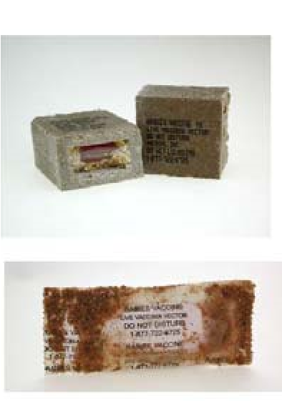
FISHMEAL

POLYMER-BASED
BAIT CONTAINING VACCINE
COATED SACHET

CONTAINING VACCINE

The oral rabies vaccine bait, shown here, consists of vaccine (dyed pink) inside a plastic sachet. The sachet is either coated with a thin fishmeal flavoring or incased into the middle of a square block made from a compressed mixture of fishmeal and fish oil known to attract raccoons. Baits are distributed from vehicles, boats, helicopters or airplanes. Most of the baits will be consumed about five days after being distributed. People should tell their children to leave the baits alone. Pet owners are asked to keep their dogs and cats inside or on leashes so raccoons can eat the baits.

Are gloves required to handle the bait or will I be harmed if I handle the intact bait without gloves?
It is not harmful to touch an intact bait, but the fish oil and odor on the bait may get on your fingers. Wear rubber or latex gloves or use a shovel to protect your hands if the bait has broken open or is damaged or leaking. As a precaution, wash your hands thoroughly after any direct contact with the bait.
What if I find a bait near my home?
Leave it alone. However, if the bait is intact and out in the open or where contact by pets or children is possible, wearing a glove, toss it into deeper cover.

What if my dog or cat eats a bait?
It is not harmful if your pet consumes a small quantity of baits. Because additional baits may have been dropped nearby, check the area for more. Any other baits can be removed and placed in areas more likely to be found by a raccoon than a pet.

Is the vaccine harmful?
The vaccine is not harmful to wild animals or pets. Although the exposure risk to humans is very slight, the following information is important: • Be aware of what a bait looks like.
- Encourage children to leave the baits alone.
- Keep dogs and cats inside or on leashes at least five days after your area has been baited.
- Do not attempt to take a bait away from your pet; you may be bitten!
- Wash your hands or exposed skin thoroughly with soap and water if you touch the bait or the liquid vaccine inside the bait.

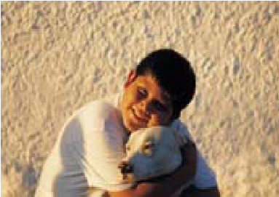
What happens if a person eats or has contact with the vaccine? Will my child get rabies?
The bait has a strong fish odor and is usually unappealing to children. It is not possible to get rabies from the vaccine. The vaccine contains only a single gene that expresses the outer layer of the rabies virus, which is set into a nonrabies "carrier" virus. People with certain medical conditions, such as an immunodeficiency problem, may be prone to a treatable infection from the carrier virus if the vaccine (pink liquid) gets into an open wound, or contacts a mucus membrane such as the eyes or mouth. Rinsing the eyes or using soap and water to wash any area exposed to the vaccine can prevent this. Please call the Pennsylvania Public Health Information Line at 1-877-PA HEALTH, the Erie Co. Department of Health at 1-814-451-6700, or the Allegheny Co. Health Department at 1-412-687-2243 if you are exposed to the vaccine or need advice.

Can this vaccine be used to vaccinate my dog or cat against rabies?
No, this vaccine is approved only for use in wildlife. A veterinarian, in accordance with state and local regulations, should vaccinate your pets. Regular pet vaccination is essential to protect your pet against rabies.

How is a raccoon vaccinated?
A raccoon is vaccinated by eating a bait containing the vaccine. The raccoon will develop antibodies in two to three weeks that may protect it if it is exposed to another infected raccoon. If enough raccoons are vaccinated, the risk of the spread of rabies will be greatly reduced.

